**3.2** **System Architecture**

After determining the requirements of the system, we will describe its major Components, their relationships (structures), and how they interact with each other.

The user can scan his skin disease with his mobile camera or upload a photo from his gallery , then the system makes an analysis , asks the user some questions and displays the result.

The user can read detailed descriptions to understand more about his result.

After reading the description, the system chooses the suitable medicine for the user based on his result , then, the user can get his medicine online and contact the nearest doctor based on the user’s location.

Our system also provides a search for any skin disease and a history of disease images that the user has scanned.

**3.3 Development Methodology**

After we knew the basic structure of the system. We are going to view all of its functions, the relation between them and the sequence of their executions in the following subparts.

**3.3.1 Use Case Diagrams**

First, with use case diagram, we will specify the expected behaviour of the system. This helps us to design the system from end user's perspective.

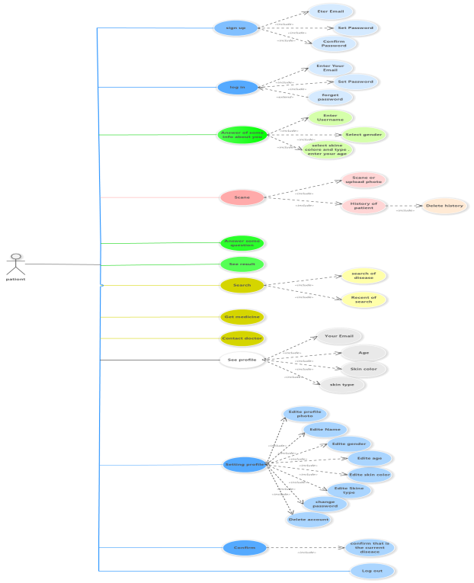

**Figure 3.1 Use case diagram**

**3.3.2 Use Case Description**

**· Use Case : DermAI**

**· Actors : (user) Patient**

**· Goal :** The project aims to develop a healthcare system Uses artificial intelligence and machine learning techniques In diagnosing diseases starting with the largest organ in the body The human skin, which is the protective shield for the body The part that is most sensitive and vulnerable to environmental influences external.

**· Description :**

**When a user scan his skin disease image , the system analyses it after the user asks some questions about his disease and explains the result in details. The system suggests to the user the appropriate medicine , contact the nearest doctor and he can search for any disease. He can also edit his profile.**

**3.3.3 Sequence Diagram**

The sequence diagrams will show you how an operation is done and the inner details of it .

To use our system, the user must be authorised first by sign up (if it is the first time) or by login (if he owns an account). Once the user logged in successfully, his corresponding record in the database.Figure 3.2 shows a sequence diagram for the authentication process.

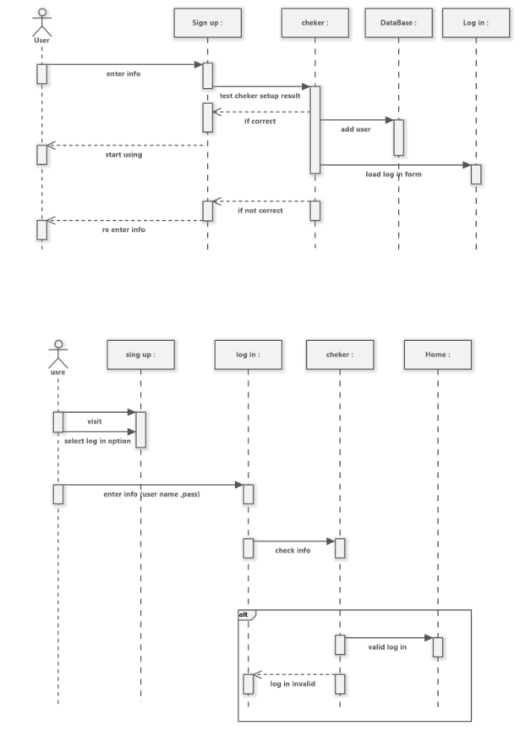

**Figure 3.2 Sign up and login sequence diagram.**

**Second step is Scan process:**

The user can scan his skin disease through his phone camera (or upload a photo from his gallery) , the system analyses it after the user asks some questions about his disease and explains the result in details. Figure 3.3 shows a sequence diagram for scan process.

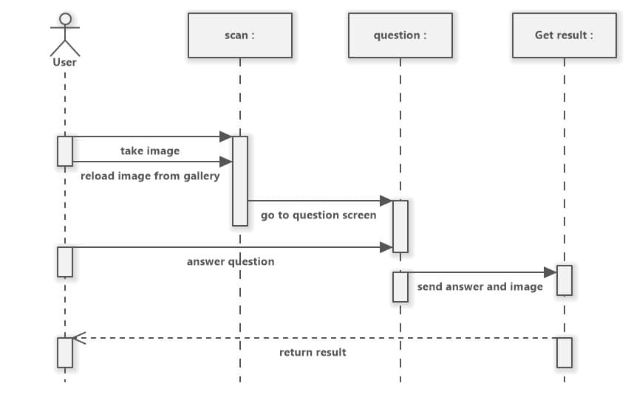

**Figure 3.3 shows a sequence diagram for scan process**

**The third step show the result :**

After the user scans the image and answers some question , the result appears to him. Figure 3.4 shows a sequence diagram for the result.

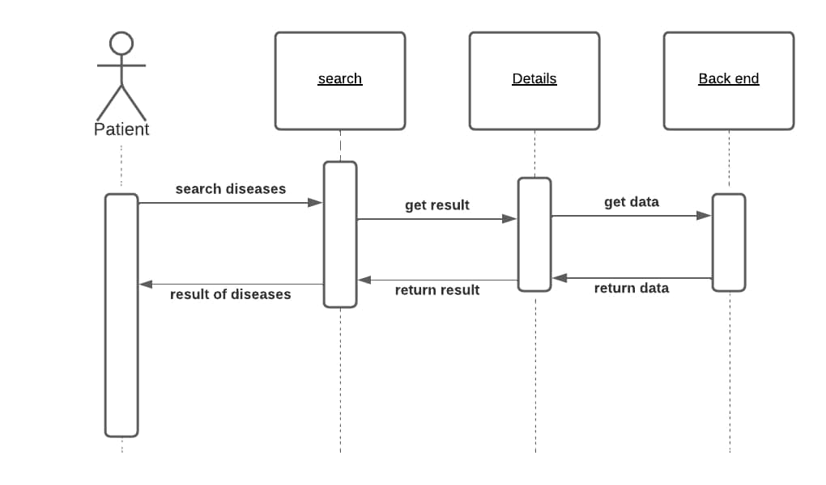

Figure 3.4 shows a sequence diagram for the result.

The fourth step shows how the user searches for any disease and gets the result. Figure 3.5 shows a sequence diagram for the search process.



Figure 3.5 shows a sequence diagram for the search process.

**3.4 Tools and Languages**

**Developing our software application can be divided into main two parts, which are the design part, the implementation part.**

**The design part involves designing diagrams and designing the user interface of the mobile application.**

**The implementation part involves programming languages, IDEs, frameworks, and libraries. The following list shows the needed tools for the software development and a brief description about their usages:**

1. **Software Ideas Modeller –** it is used to draw the UML diagrams.
2. **Adobe XD –** it is used to design user interfaces and prototypes.
3. **Android Studio –** it is an IDE to build mobile applications for Android OS.
4. **Postman –** it is an HTTP client that tests HTTP requests.
5. **Visual Studio –** it is a set of development tools available in the form of visual studio add-in.
6. **PhpMyAdmin –** Open source administration tool for MySQL and MariaDB.
7. **Skipper –** it is a visualisation tool and code/schema generator for PHP ORM framework.

**3.5 Summary**

**In this chapter we provide the reader with detailed knowledge about our system. Part 3.1 includes system requirements Which is divided into functional , non-functional and user requirements which specify some different specifications for users. Part 3.2 includes system architecture which describes the main components of the system, their relationships, and how they interact with each other. Part 3.3 includes a development methodology which includes UML diagrams that show the details of how the system will work. In the end of the chapter we listed the needed tools to build the system.**